COURSE: DevOps and Cloud (IBM)
(24UAMAE201)
Academic Year 2026-2027

SUBMITTED TO
Mr. Karan Gaikwad Sir
SUBMITTED BY
Mujmule Snehal (PRN: 2125UDSF1078)
Step 1: Log in and select the region
➢ The AWS Management Console after login, with the region set to Asia Pacific (Sydney). All resources for the Library Management Platform are created in this region.
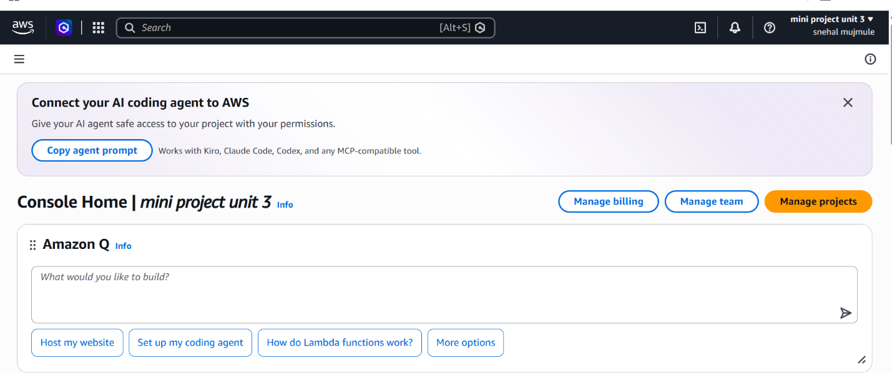
Step 2: Create a key pair
➢ A key pair named library-key was created. For Windows servers, the private key is used to decrypt the Administrator password needed for Remote Desktop login
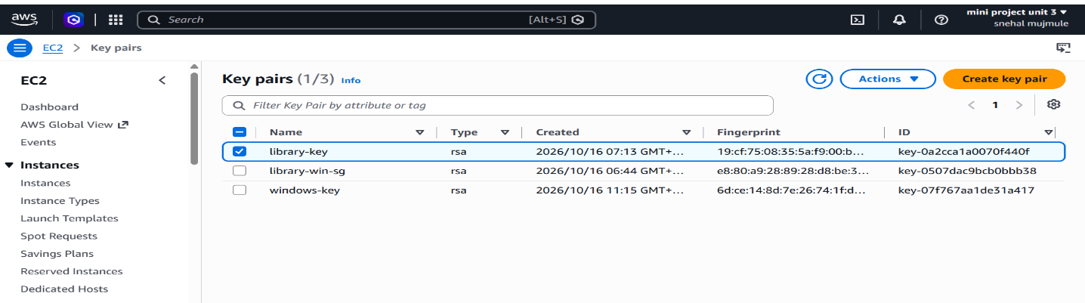
Step 3: Create the security group
➢ The inbound rules tab of library-win-sg: Security group works as a virtual firewall. It allows RDP (3389) only from my IP for secure administration and HTTP (80) from anywhere so users can access the library website.
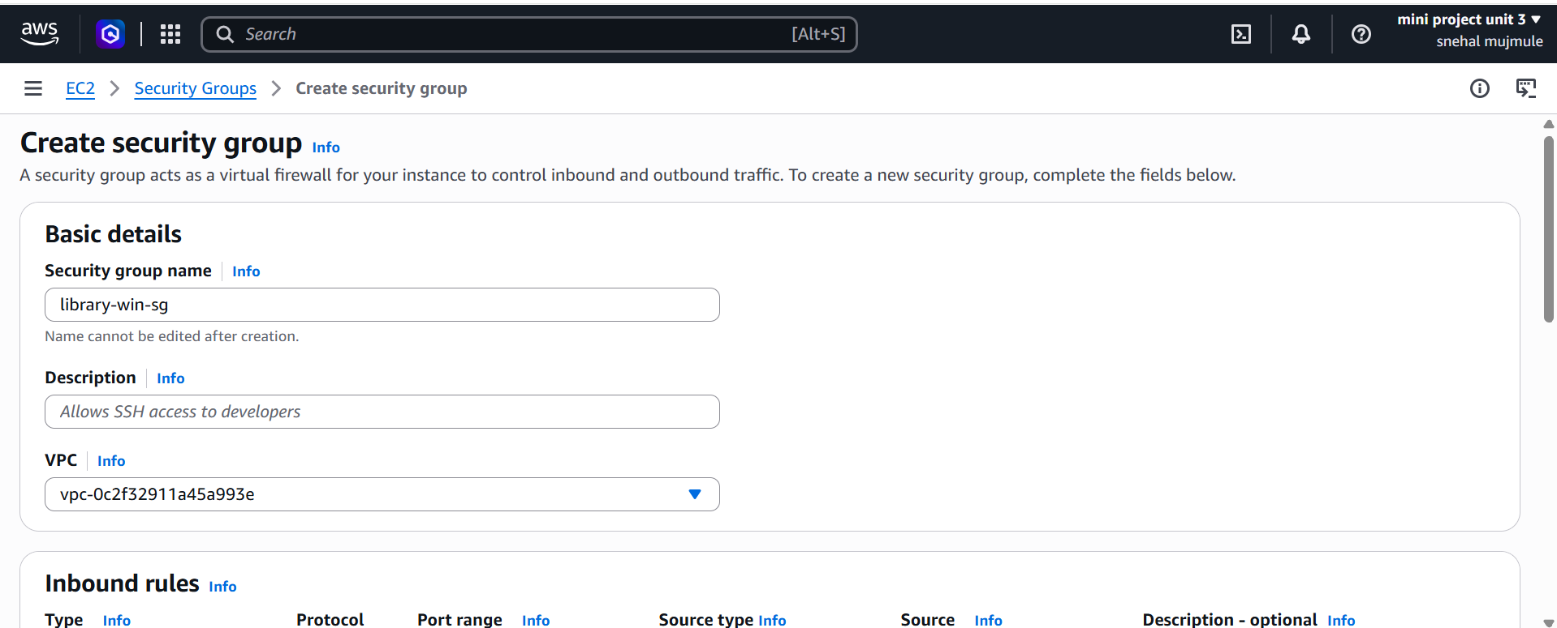
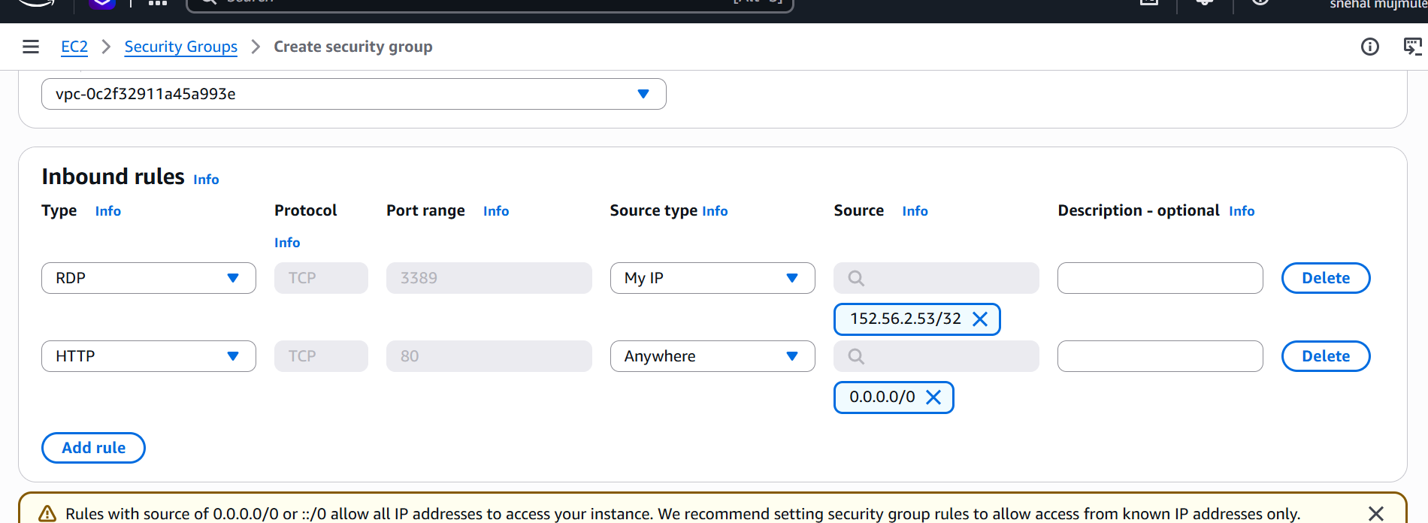
Step 4: Launch the Windows EC2 instance
➢ A Windows Server 2022 EC2 instance named library-win-server is configured with the key pair and security group created earlier. It hosts the application tier of the platform.
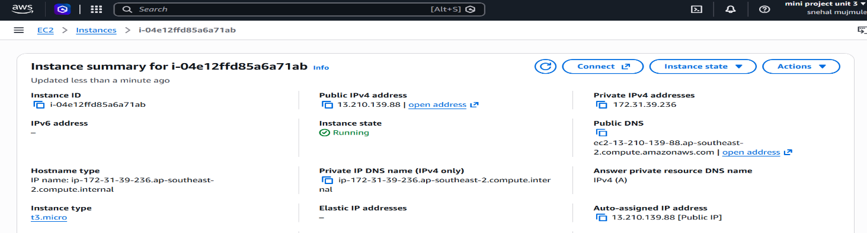

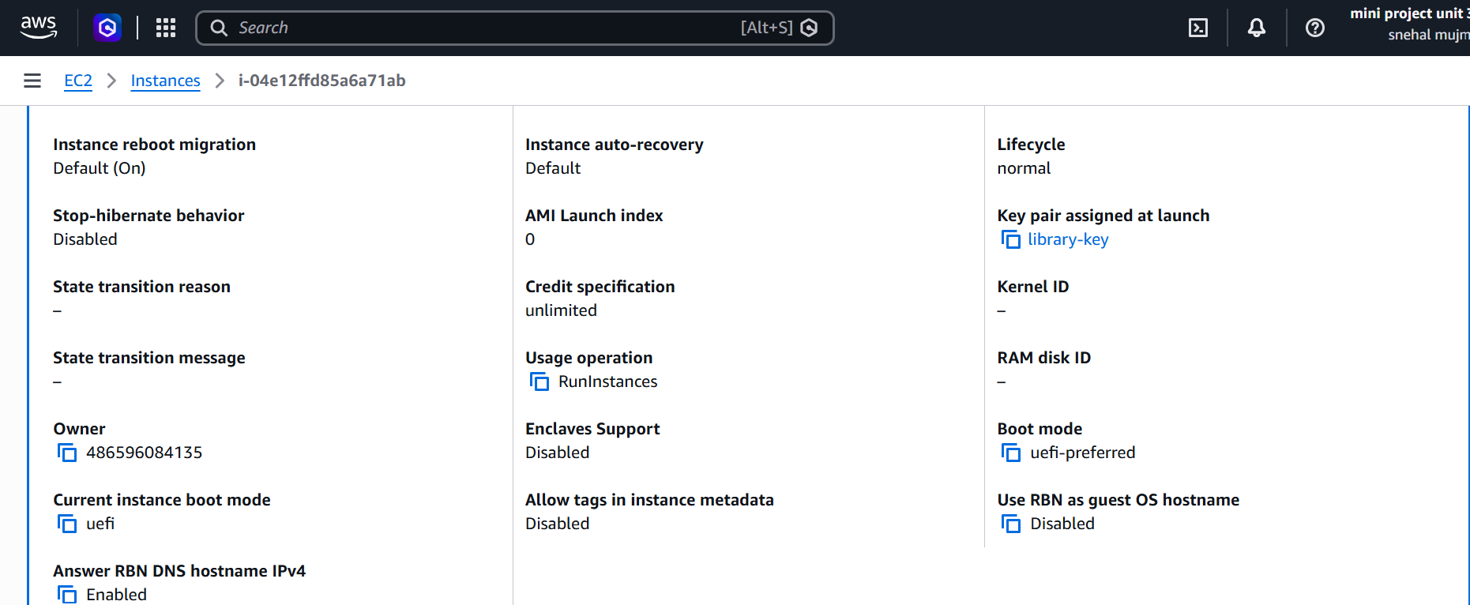
➢ The Windows instance is running and all status checks have passed. Its public IP address is used for both Remote Desktop and the website.
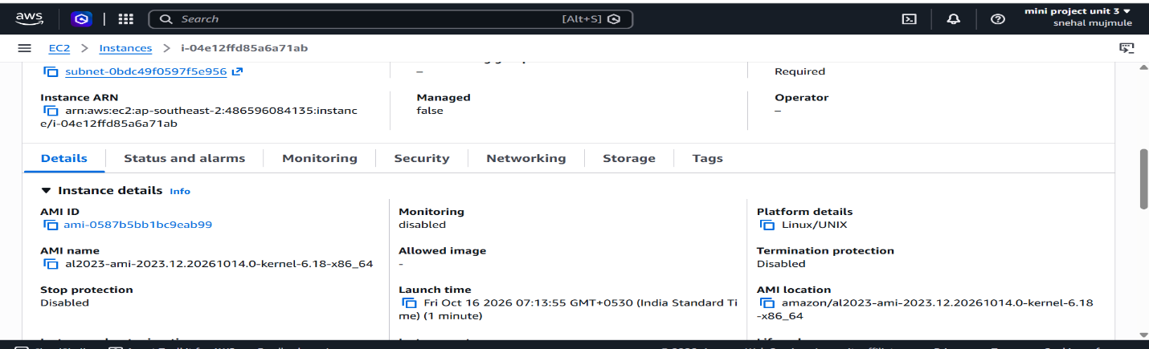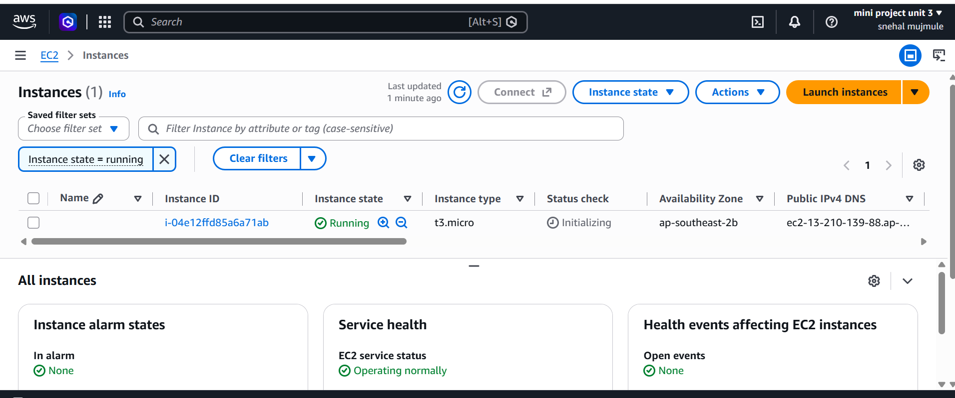
Step 5: Get the password and connect with Remote Desktop
➢ The Administrator password was retrieved by decrypting it with the private key. This ensures only the key holder can access the server."
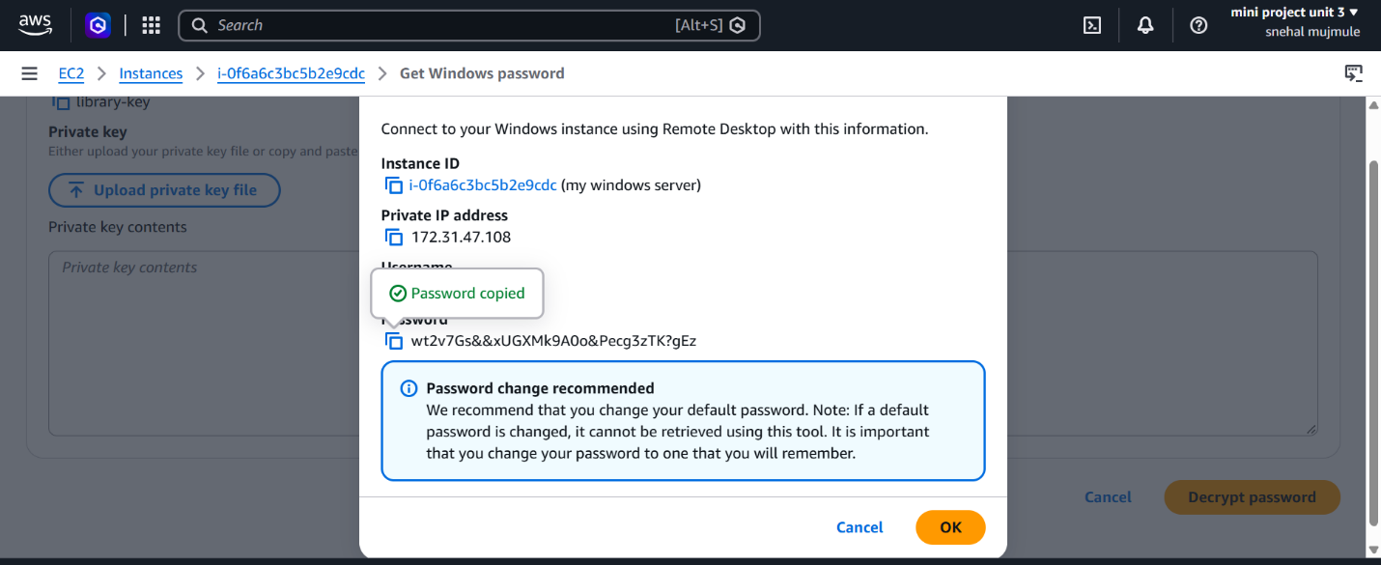
➢ Successfully connected to the AWS Windows Server using Remote Desktop. All further setup is done on this server.
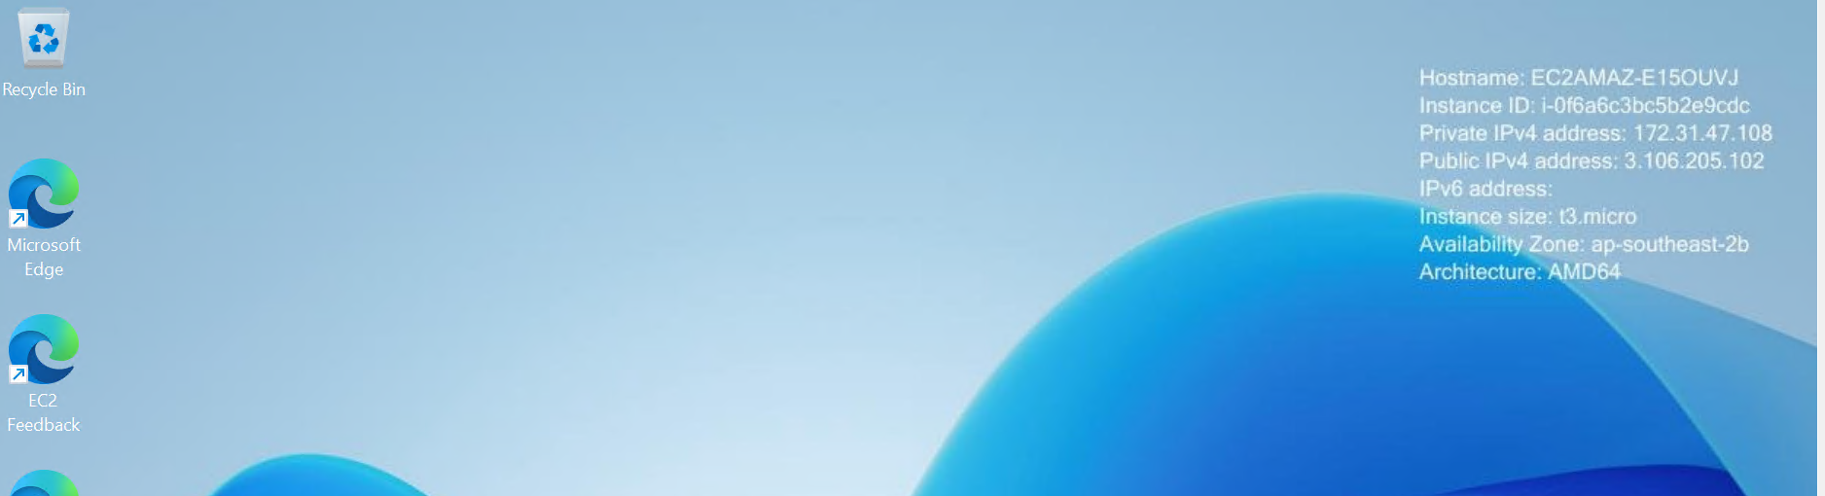
Step 6: Install Python on the server
➢ Python and the Flask web framework were installed on the server. Waitress is the production web server used to run the application on Windows.
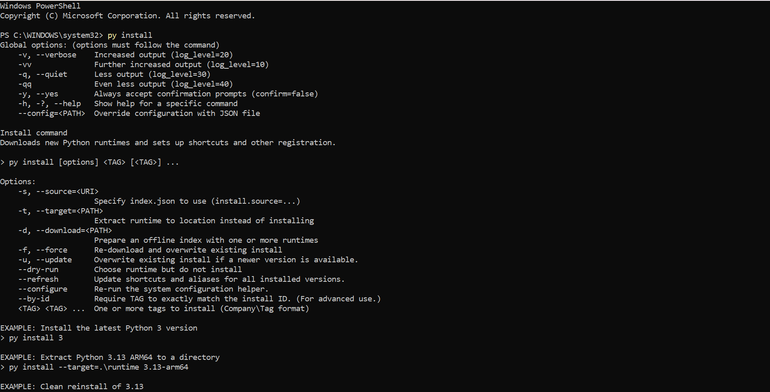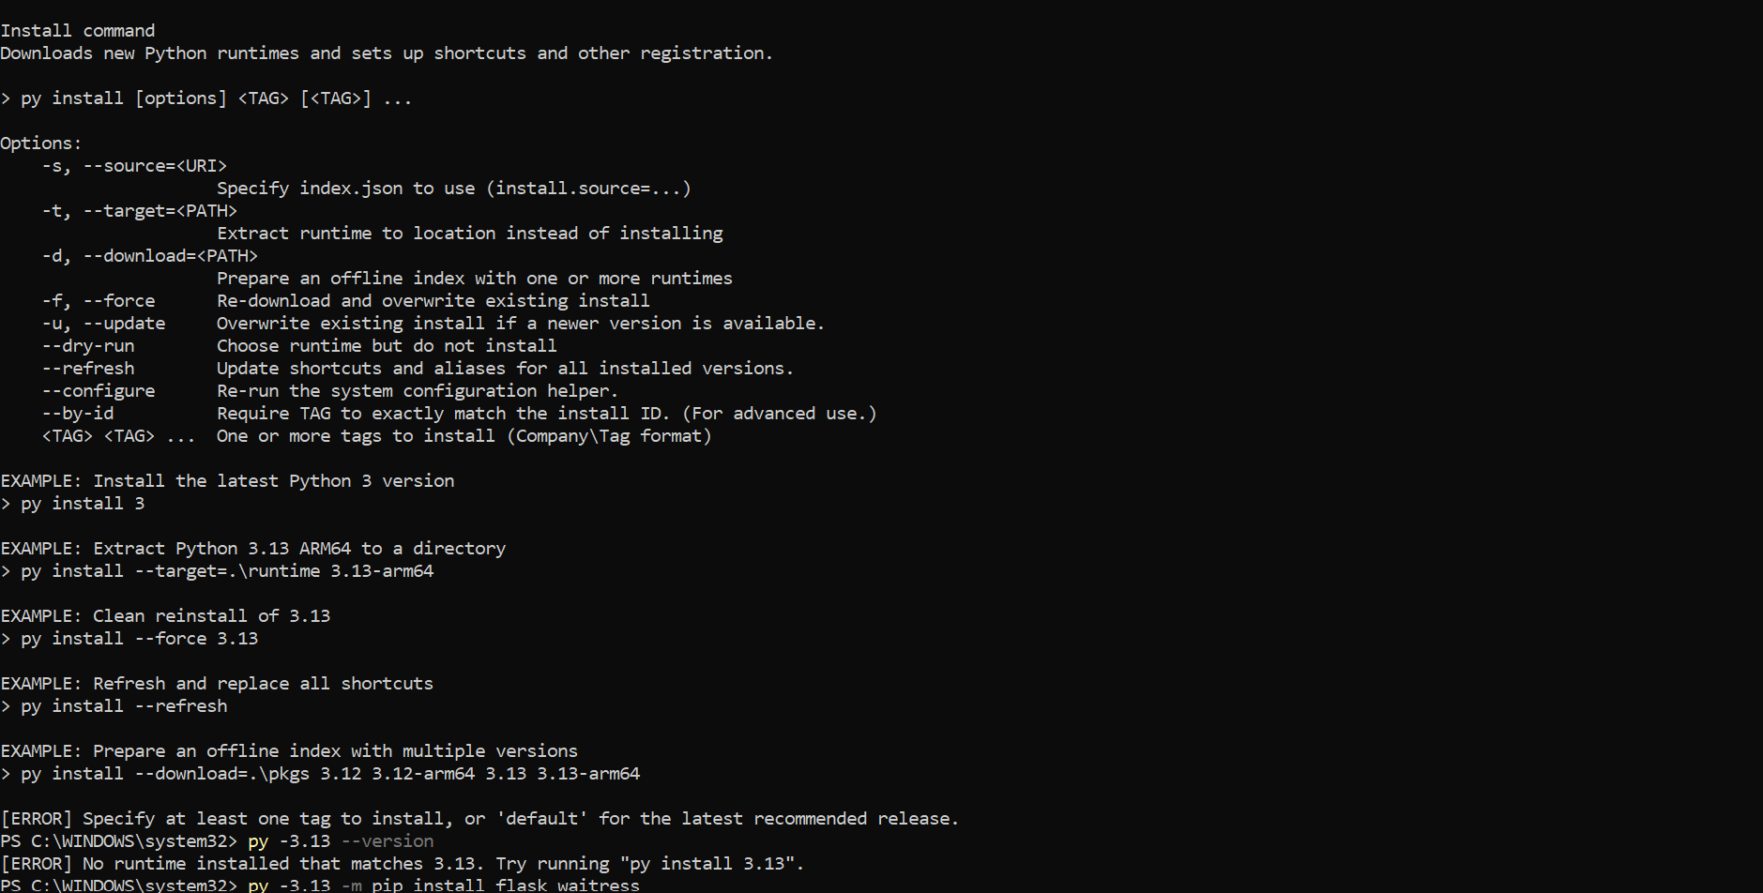
Step 7: Create the application
➢ The application source code was created in C:\library. It implements book search, issue with a 14-day due date, and return with automatic fine calculation at Rs 5 per overdue day, as defined in the MVP scope.
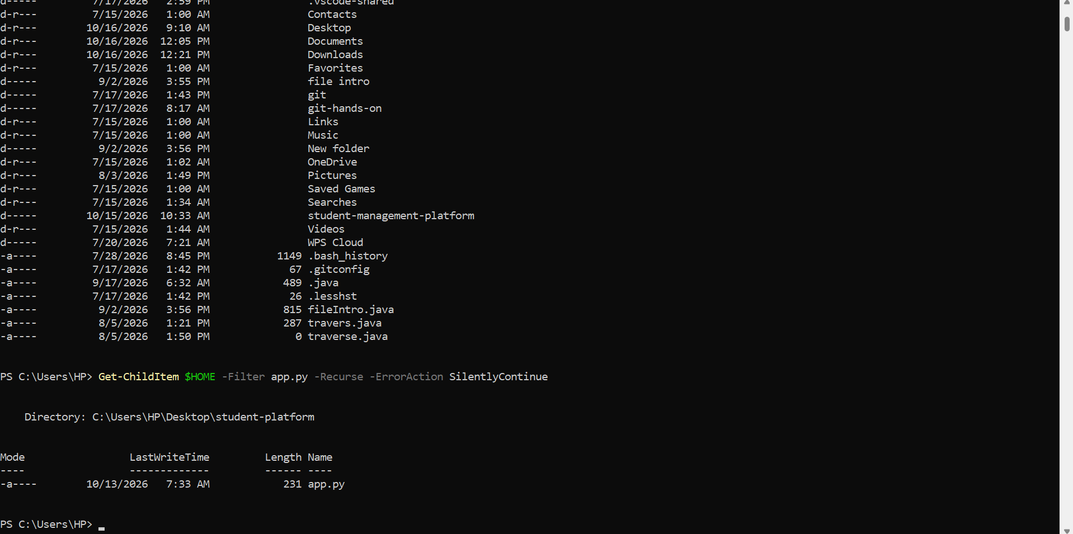
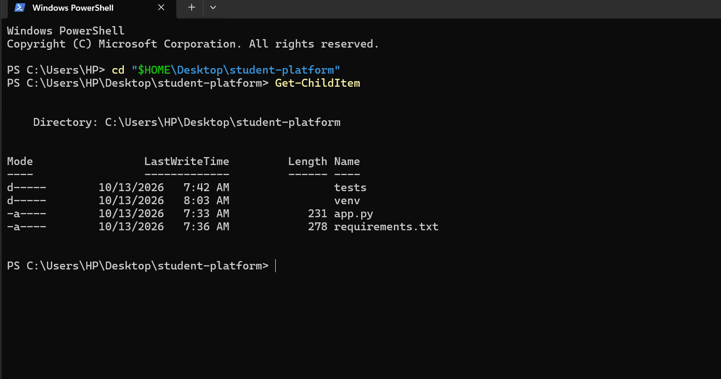

Step 8: Open Port 5000 in Windows Firewall
An inbound rule was created in Windows Defender Firewall to allow TCP traffic on port 5000. This allows incoming requests to reach the application running on the Windows server. The AWS Security Group must also be configured to allow inbound traffic on port 5000. Both firewall settings are required for the application to be accessible through a web browser.
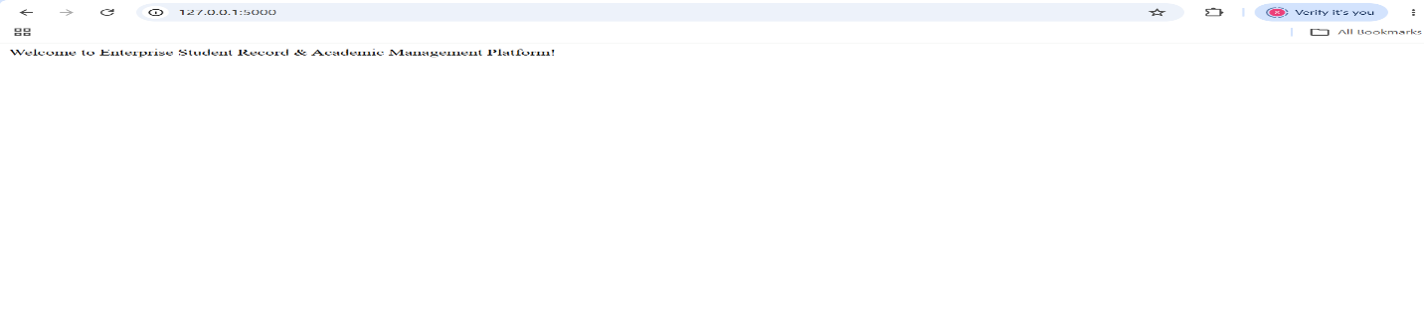
Step 9: Run the application
➢ The Library Management Platform is running on the Windows server through the Waitress web server
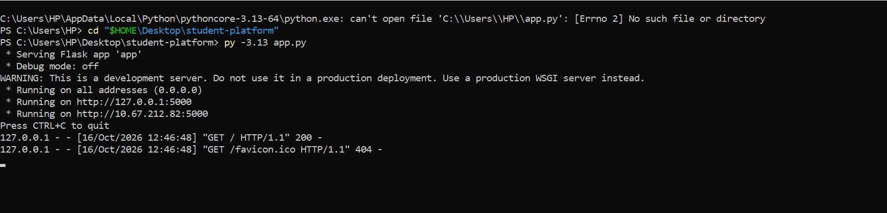Step 10: Open the website
➢ The Library Management Platform running live on AWS Windows Server, showing the catalog with availability status.